LAMPIRAN
Riwayat Hidup
Nama Lengkap : Yulita Norma Sari
Tempat & Tanggal Lahir : Banjarmasin, 29 Juli 1998
Jenis Kelamin : Perempuan
Agama : Islam
Kebangsaan : Indonesia
Status Perkawinan : Belum Kawin
Alamat : Jalan A. Yani, Karang Paci, RT 04 No. 102 Kel. Karang Mekar, Kec Banjarmasin Timur, Kota Banjarmasin
Riwayat Pendidikan :
- SDN Kuningan Timur 02 Pagi Jakarta Tahun 2010
- SMPN 57 Jakarta Tahun 2013
- SMAN 3 Jakarta Tahun 2016
Pengalaman Organisasi :
- Anggota LDK Al-Fatih 2018
- Anggota Divisi SDM KSPM Antasari 2018
- Anggota FoSSEI Regional Kalsel 2018
- Ketua Bidang Ekonomi LDK Al-Fatih 2019
- Bendahara Umum Regional FoSSEI Regional Kaltim-sel 2019
- Sekretaris Divisi SDM KSPM Antasari 2019

Orang Tua :
Ayah : Suriyatno
Pekerjaan : Karyawan Swasta
Ibu : Noor Hasanah
Pekerjaan : Ibu Rumah Tangga
Saudara : Anak ke-1 (Pertama) dari 2 bersaudara

Lampiran : Data Penelitian
Data Entry Variabel

Tahun | Emiten | PBV | DER | ROE | EPS | Return
2015 | ADRO | 0,36 | 0,78 | 0,05 | 65,74 | 0,72
 | AKRA | 3,89 | 1,09 | 0,15 | 262,36 | 0,79
 | ASII | 1,92 | 0,94 | 0,12 | 357,31 | 0,74
 | BSDE | 1,57 | 0,63 | 0,11 | 122,17 | 0,83
 | ICBP | 4,79 | 0,62 | 0,18 | 514,62 | 0,82
 | INDF | 1,05 | 1,13 | 0,09 | 338,02 | 0,80
 | KLBF | 5,66 | 0,25 | 0,19 | 42,76 | 0,81
 | PGAS | 1,60 | 1,15 | 0,13 | 242,58 | 0,80
 | SMGR | 2,46 | 0,39 | 0,16 | 762,28 | 0,82
 | SMRA | 3,16 | 1,49 | 0,14 | 73,76 | 0,86
 | TLKM | 3,35 | 0,78 | 0,25 | 153,66 | 0,85
 | UNTR | 1,61 | 0,57 | 0,07 | 1.033,07 | 0,76
 | UNVR | 58,48 | 2,26 | 1,21 | 766,95 | 0,76
 | WIKA | 2,99 | 2,60 | 0,13 | 114,32 | 0,82
2016 | ADRO | 1,18 | 0,72 | 0,09 | 140,56 | 0,93
 | AKRA | 3,06 | 0,96 | 0,13 | 253,22 | 0,83
 | ASII | 2,54 | 0,87 | 0,13 | 374,37 | 0,87
 | BSDE | 1,44 | 0,57 | 0,08 | 105,86 | 0,94
 | ICBP | 5,61 | 0,56 | 0,20 | 617,45 | 1,02
 | INDF | 1,55 | 0,87 | 0,12 | 472,02 | 0,95
 | KLBF | 6,01 | 0,22 | 0,19 | 49,06 | 0,93
 | PGAS | 1,62 | 1,16 | 0,10 | 168,67 | 0,93
 | SMGR | 1,91 | 0,45 | 0,15 | 762,30 | 0,91
 | SMRA | 2,48 | 1,55 | 0,07 | 41,94 | 0,92
 | TLKM | 4,23 | 0,70 | 0,28 | 171,93 | 0,85
 | UNTR | 1,97 | 0,50 | 0,12 | 1.341,03 | 0,87
 | UNVR | 46,67 | 2,56 | 1,36 | 837,57 | 0,84
 | WIKA | 3,71 | 1,49 | 0,09 | 127,89 | 0,93

2017 | ADRO | 1,07 | 0,67 | 0,13 | 204,71 | 0,94
 | AKRA | 2,82 | 0,86 | 0,14 | 299,94 | 0,85
 | ASII | 2,15 | 0,89 | 0,15 | 466,39 | 0,75
 | BSDE | 1,12 | 0,57 | 0,18 | 269,59 | 0,93
 | ICBP | 5,11 | 0,56 | 0.17 | 325,55 | 0,92
 | INDF | 1,43 | 0,88 | 0,11 | 474,75 | 0,92
 | KLBF | 5,97 | 0,20 | 0,18 | 51,28 | 0,93
 | PGAS | 0,98 | 0,97 | 0,05 | 80,00 | 0,88
 | SMGR | 1,93 | 0,61 | 0,07 | 339,54 | 0,93
 | SMRA | 1,65 | 1,59 | 0,06 | 36,91 | 0,93
 | TLKM | 3,99 | 0,77 | 0,29 | 219,69 | 0,93
 | UNTR | 2,78 | 0,73 | 0,16 | 1.984,64 | 0,87
 | UNVR | 82,44 | 2,65 | 1,35 | 918,03 | 0,87
 | WIKA | 0,95 | 2,12 | 0,09 | 151,18 | 0,89
2018 | ADRO | 0,60 | 0,66 | 0,08 | 164,19 | 0,81
 | AKRA | 1,80 | 1,15 | 0,07 | 323,21 | 0,81
 | ASII | 1,98 | 0,98 | 0,13 | 421,73 | 0,50
 | BSDE | 0,81 | 0,75 | 0,03 | 45,56 | 0,98
 | ICBP | 5,56 | 0,54 | 0,16 | 298,83 | 0,84
 | INDF | 1,35 | 0,98 | 0,08 | 321,16 | 0,83
 | KLBF | 4,89 | 0,20 | 0,13 | 38,49 | 0,92
 | PGAS | 1,04 | 1,01 | 0,07 | 134,34 | 0,95
 | SMGR | 2,15 | 0,60 | 0,07 | 351,91 | 0,95
 | SMRA | 1,34 | 1,63 | 0,05 | 27,19 | 0,94
 | TLKM | 3,50 | 0,93 | 0,19 | 141,19 | 0,91
 | UNTR | 1,87 | 0,97 | 0,17 | 2.432,04 | 0,81
 | UNVR | 38,62 | 1,58 | 1,20 | 1.193,90 | 0,82
 | WIKA | 0,96 | 2,70 | 0,07 | 117,86 | 0,94

Lampiran : Hasil Analisis
Statistik Deskriptif

Descriptive Statistics
 | N | Minimum | Maximum | Mean | Std. Deviation
Ln_X1 (PBV) | 56 | 3,58 | 9,02 | 5,5768 | 1,04881
Ln_X2 (DER) | 56 | 3,00 | 5,60 | 4,4436 | ,60528
Ln_X3 (ROE) | 56 | 1,10 | 4,91 | 2,6086 | ,77812
Ln_X4 (EPS) | 56 | 7,91 | 12,40 | 10,0078 | 1,04963
RETURN | 56 | 50.00 | 102.00 | 86.5179 | 8.32956
Valid N (listwise) | 56

Grafik Uji Normalitas

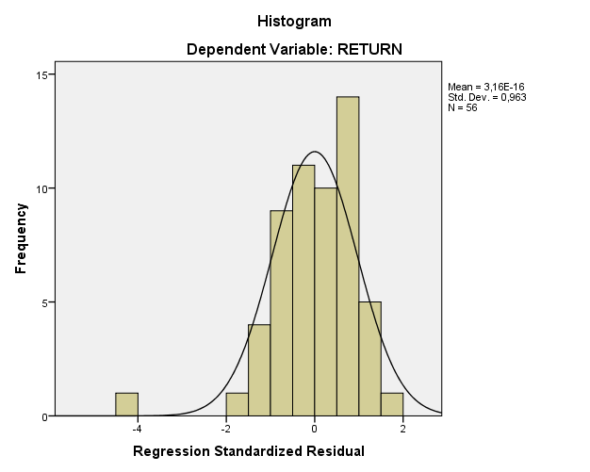

Normal P-P Plot Uji Normalitas

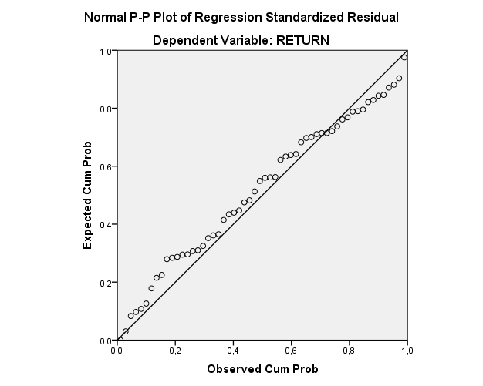

Uji Normalitas One Sample K-S

One-Sample Kolmogorov-Smirnov Test
 |  | Unstandardized Residual
N |  | 56
Normal Parameters^{a,b} | Mean | ,0000000
 | Std. Deviation | 7,85099861
Most Extreme Differences | Absolute | ,111
 | Positive | ,074
 | Negative | -,111
Test Statistic |  | ,111
Asymp. Sig. (2-tailed) |  | ,083^{c}
a. Test distribution is Normal.
b. Calculated from data.
c. Lilliefors Significance Correction.

Uji Multikolinieritas

Coefficientsª
Model |  | Unstandardized Coefficients |  | Standardized Coefficients | t | Sig. | Collinearity Statistics
 |  | B | Std. Error | Beta |  |  | Tolerance | VIF
1 | (Constant) | 104,611 | 15,471 |  | 6,762 | ,000
 | Ln_X1 (PBV) | 2,665 | 2,477 | ,336 | 1,076 | ,287 | ,179 | 5,584
 | Ln_X2 (DER) | -1,494 | 1,843 | -,109 | -,810 | ,421 | ,971 | 1,030
 | Ln_X3 (ROE) | -4,086 | 3,505 | -,382 | -1,166 | ,249 | ,162 | 6,156
 | Ln_X4 (EPS) | -1,565 | 1,171 | -,197 | -1,336 | ,187 | ,800 | 1,250
a. Dependent Variable: RETURN

Uji Heteroskedastisitas

Coefficientsª
Model |  | Unstandardized Coefficients |  | Standardized Coefficients | T | Sig.
 |  | B | Std. Error | Beta
1 | (Constant) | 4,827 | 9,997 |  | ,483 | ,631
 | Ln_X1 (PBV) | -2,076 | 1,601 | -,412 | -1,297 | ,200
 | Ln_X2 (DER) | ,091 | 1,191 | ,010 | ,077 | ,939
 | Ln_X3 (ROE) | 1,532 | 2,265 | ,226 | ,676 | ,502
 | Ln_X4 (EPS) | ,810 | ,757 | ,161 | 1,070 | ,290
a. Dependent Variable: RES3

Uji Autokorelasi

Model Summary^{b}
Model | R | R Square | Adjusted R Square | Std. Error of the Estimate | Durbin-Watson
1 | ,334ª | ,112 | ,042 | 8.15307 | 1,569
a. Predictors: (Constant), Ln_X4, Ln_X2, Ln_X1, Ln_X3
b. Dependent Variable: RETURN

Analisis Regresi Linier Berganda

Coefficientsª
Model |  | Unstandardized Coefficients |  | Standardized Coefficients | t | Sig.
 |  | B | Std. Error | Beta
1 | (Constant) | 104,611 | 15,471 |  | 6,762 | ,000
 | Ln_X1 (PBV) | 2,665 | 2,477 | ,336 | 1,076 | ,287
 | Ln_X2 (DER) | -1,494 | 1,843 | -,109 | -,810 | ,421
 | Ln_X3 (ROE) | -4,086 | 3,505 | -,382 | -1,166 | ,249
 | Ln_X4 (EPS) | -1,565 | 1,171 | -,197 | -1,336 | ,187
a. Dependent Variable: RETURN

Uji Simultan (Uji F)

ANOVAª
Model |  | Sum of Squares | df | Mean Square | F | Sig.
1 | Regression | 425,882 | 4 | 106,471 | 1,602 | ,188^{b}
 | Residual | 3390,100 | 51 | 66,473
 | Total | 3815,982 | 55
a. Dependent Variable: RETURN
b. Predictors: (Constant), Ln_X4, Ln_X2, Ln_X1, Ln_X3

Uji Parsial (Uji T)

Coefficientsª
Model |  | Unstandardized Coefficients |  | Standardized Coefficients | t | Sig.
 |  | B | Std. Error | Beta
1 | (Constant) | 104,611 | 15,471 |  | 6,762 | ,000
 | Ln_X1 (PBV) | 2,665 | 2,477 | ,336 | 1,076 | ,287
 | Ln_X2 (DER) | -1,494 | 1,843 | -,109 | -,810 | ,421
 | Ln_X3 (ROE) | -4,086 | 3,505 | -,382 | -1,166 | ,249
 | Ln_X4 (EPS) | -1,565 | 1,171 | -,197 | -1,336 | ,187
a. Dependent Variable: RETURN

Lampiran : Tabel Statistik
