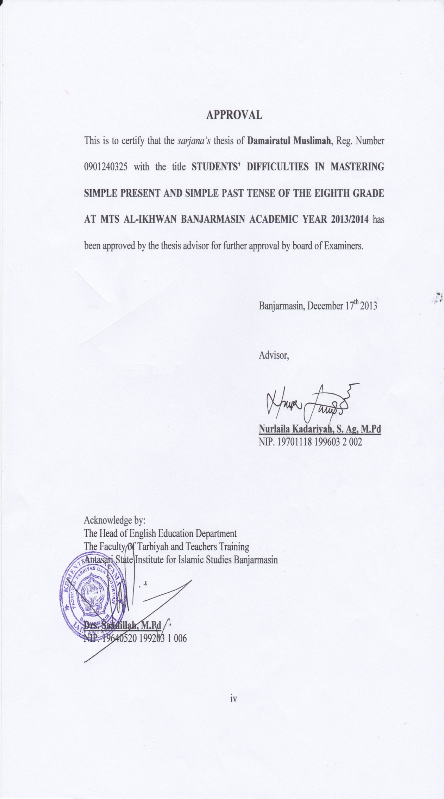
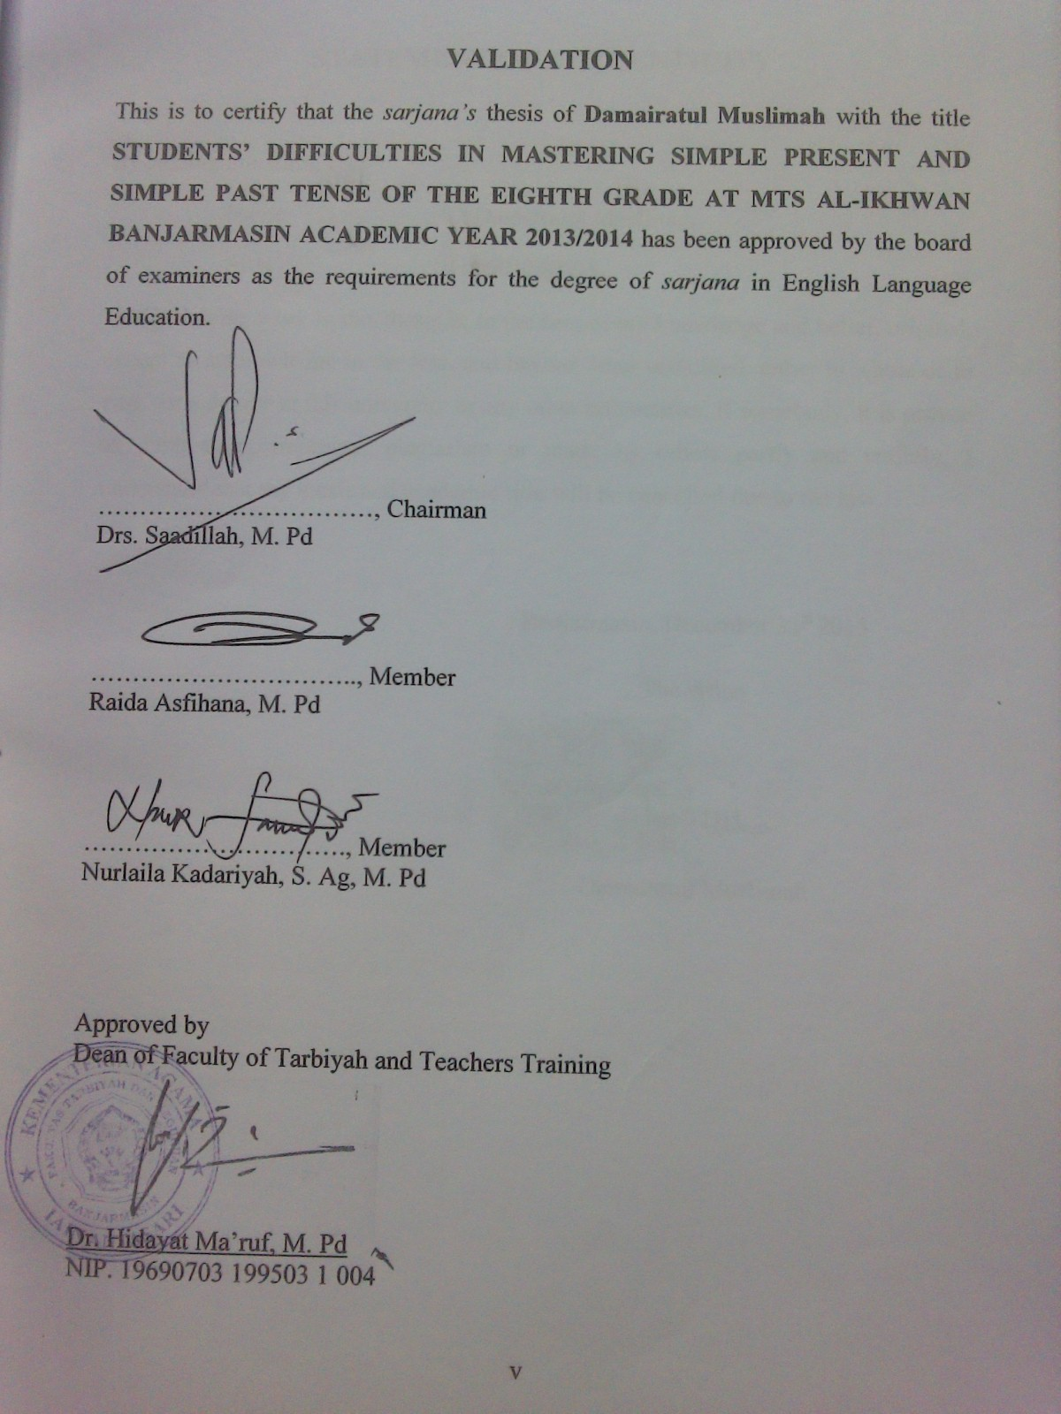
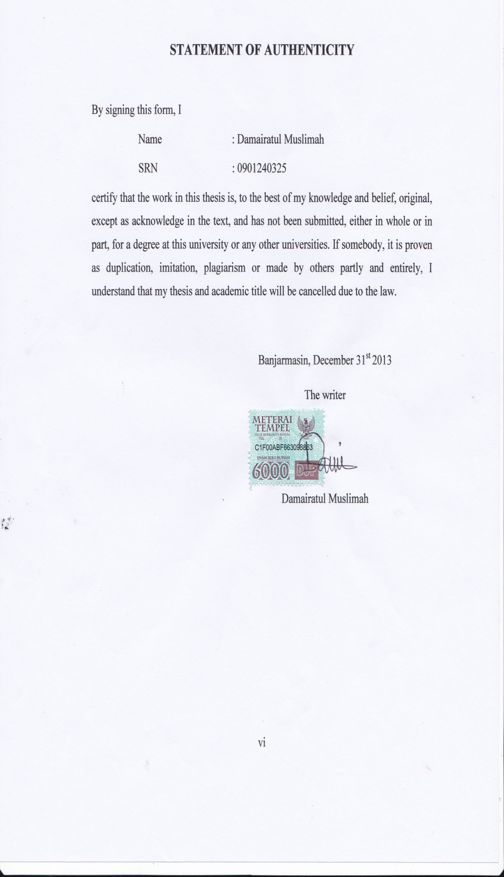
ABSTRACT
Damairatul Muslimah. 2014. Students’ Difficulties in Mastering Simple Present and Simlpe Past Tense of The Eighth Grade MTs Al-Ikhwan Banjarmasin Academic Year 2013/2014. Thesis. English Education Department, The Faculty of Tarbiyah and Teachers Training. Advisor: Nurlaila Kadariyah S.Ag, M. Pd.
Keywords: Difficulties, Mastery, Simple Present Tense, Simple Past Tense.
The problem formulations of this research are: 1). What are students’ difficulties in mastering in simple present? 2). What are students’ difficulties in mastering simple past tense?
The subject of this research is 97 students of the eighth grade at MTs Al-Ikhwan Banjarmasin academic year 2013/2014. The objects of this research are the students’ difficulties in mastering simple present tense and students’ difficulties in mastering simple past tense by answering questions about simple present and simple past tense.
To collect the data, the writer uses some techniques such as written test observation and documentary. Data processing in this research is divided into four phases: checking, scoring, classifying, and interpreting. Then, all the data are analyzed descriptively, quantitatively and concluded inductively.
The result of this research shows that students’ difficulties in mastering simple present and simple past tense is in average difficulty category because the mean of the test result is 49. 4. Based on two types of test for each tenses, for students’ difficulties in mastering simple present; in multiple choice test and word completion, there are some aspects of the students’ difficulties in mastering simple present tense; they are putting the correct subject, choosing to be in nominal sentence, changing verb (plural and singular subject), using do/does question and choosing adverb. For students’ difficulties in mastering simple past tense; in multiple choice test and word completion, there are some aspects of the students’ difficulties in mastering simple past tense; they are choosing to be in nominal sentence, using subject, changing verb2 (regular and irregular form), changing the sentence form in positive, negative and interrogative and adverb.

ABSTRAK
Damairatul Muslimah. 2014. Kesulitan Siswa dalam Menguasai Simple Present dan Simple Past Tense Kelas Delapan pada MTs A-Ikhwan Banjarmasin Tahun Ajaran 2013/2014. Skripsi. Jurusan Tadris Bahasa Inggris. Fakultas Tarbiyah dan Keguruan. Pembimbing: Nurlaila Kadariyah S. Ag, M. Pd.
Kata kunci: Kesulitan, Penguasaan, Simple Present Tense, Simple Past Tense.
Rumusan masalah pada penelitian ini adalah: 1). Apa saja kesulitan siswa dalam menguasai simple present tense? 2). Apa saja kesulitan siswa dalam menguasai simple past tense?
Subjek dalam penelitian ini adalah 97 orang dari kelas VIII di MTs Al-Ikhwan Banjarmasin tahun ajaran 2013/2014. Sedangkan objek penelitian ini adalah kesulitan siswa dalam menguasai simple present tense dan kesulitan siswa dalam menguasai simple past tense.
Untuk mengumpulkan data, penulis menggunakan beberapa teknik seperti melaksanakan tes tertulis, observasi dan dokumentasi. Proses pengolahan data dalam penelitian ini dibagi kedalam empat tahap: pengecekan, penilaian, pengklasifikasian dan interpretasi. Kemudian, semua data di analisis secara deskriptif, kuantitatif dan di simpulkan secara induktif.
Hasil penelitian ini menunjukkan bahwa kesulitan siswa dalam menguasai simple present dan simple past tense kelas VIII MTs Al-Ikhwan Banjarmasin termasuk dalam kategori kesulitan yang cukup, karena hasil rata-rata tes mereka adalah 49,4. Berdasarkan pada dua jenis tes untuk masing-masing tenses, kesulitan siswa dalam menguasai simple present tense dalam tes pilihan ganda dan melengkapi kata, ada beberapa aspek-aspek dari kesulitan siswa yaitu pemilihan subjek yang benar, “to be” dalam kalimat nominal, perubahan kata kerja (untuk subjek jamak dan tunggal), penggunaan kata tanya do/does dan kata keterangan. Kesulitan siswa dalam menguasai simple past tense dalam tes pilihan ganda dan melengkapi kata, ada beberapa aspek-aspek dari kesulitan siswa yaitu “to be” dalam kalimat nominal, pemilihan subjek yang benar, perubahan kata kerja kedua (baik kata kerja beraturan atau kata kerja tak beraturan), penggunaan, perubahan kalimat dalam bentuk positive, negative ataupun kalimat tanya dan kata keterangan.

MOTTO

LIFE IS A STRUGGLE
LIFE IS A LEARNING
WHEN YOU HAVE NEVER MADE ​​A MISTAKE, IT MEANS YOU HAVE NOT TRIED ANYTHING

DEDICATION

Thanks to Allah SWT for everything and always keeps blessing me until now and forever.
This thesis is dedicated to:
My beloved father and mother who always pray and support me
My beloved sister (Rusmawati) and brothers (Musa, Ismail and Ishaq)
My beloved aunts (Mayang, Cibung and Lulu) who have always supported and helped my study since in elementary school until in this university
All of my lecturers especially my advisor (Nurlaila Kadariyah S. Ag, M. Pd) who always supports and patiently guides me until finishes this thesis
All of my friends 2009 class A in English Department and all of my friends in Boarding House Nusantara
(Eka Damayanti, Siti Nurhalimah, and Norhikmah)
Thank for your support
Thank for everything…

ACKNOWLEDGMENT
بسم الله الر حمن الر حيم
الحمد لله رب العا لمين .والصلاة والسلام على اشرف الاء نبياء والمرسلين سيدنا ومولنا محمد وعلى اله وصحبه اجمعين. اما بعد.
Praise be to Allah the Almighty who has been giving me guidance till the writer finished this thesis entitled “Students’ Difficulties in Mastering Simple Present and Simple Past Tense of The Eighth Grade at MTs Al-Ikhwan Banjarmasin Academic Year 2013/2014.”. Peace and salutation always be upon Prophet Muhammad P.B.U.H and his companions who struggle for Allah, as well as his followers until the end of the day.
The writer would like to express appreciation and gratitude to:
- Dr. Hidayat Ma’ruf, M.Pd., as the Dean of Tarbiyah and Teachers Training Faculty of Antasari State Institute for Islamic Studies and all his staff for their help in the administrative matters.
- Drs. Sa’adillah, M. Pd., as the Head of English Education Department for the guidance and encouragement.
- Nurlaila Kadariyah S. Ag, M. Pd, as my advisor who gives the writer much time to consult, direction, suggestion, correction and knowledge of value for the writer from beginning until this thesis finished.

- Aliansyah, S.Ag., M.Pd, as the Head of MTs Al-Ikhwan Banjarmasin, Hj. Rabiatul Adawiyah, S.Pd as the English teacher of the eighth grade and administration staff of MTs Al-Ikhwan Banjarmasin who are very helpful to the writer in conducting this research.
- All of the eighth grade students at MTs Al-Ikhwan Banjarmasin who participated in this research.
- All lecturers who have given the writer knowledge and advice.
- The head of Central Library IAIN Antasari and the head of Tarbiyah and Teachers Training Faculty library, as well as the librarians who have helped and facilitated the writer an obtaining all the needed literatures.
Finally, the writer hopes that this research paper will be useful for the next researchers. The writer admits that this research paper is not perfect yet. Therefore, suggestion will be expected to make it better.
Banjarmasin, 27 Shafar 1435 H
December, 30th 2013 A.D

Writer

CONTENTS
Page
COVER PAGE i
LOGO PAGE ii
TITLE PAGE iii
APPROVAL iv
VALIDATION v
STATEMENT OF AUTHENTICITY vi
ABSTRACT vii
ABSTRAK viii
MOTTO ix
DEDICATION x
ACKNOWLEDGEMENT xi
CONTENTS xiii
LIST OF TABLES xvi
LIST OF APPENDICES xvii

CHAPTER I : INTRODUCTION
- Background of Study 1
- Statements of Problem 6
- Objective of Study 6
- Significance of Study 6
- Definition of Key Terms 7

CHAPTER II : THEORETICAL REVIEW
- Theory of Teaching Grammar 8
- Simple Present Tense 12
- Definition of Simple Present Tense 12
- The Usage of Simple Present Tense 13
- Pattern of Simple Present Tense 19
- Simple Past Tense 27
- Definition of Simple Past Tense 27
- The Usage of Simple Past Tense 28
- Pattern of Simple Past Tense 30
- Rules of English Spelling for Simple Past Tense 32

CHAPTER III : RESEARCH METHOD
- Research Design 33
- Research Setting 33
- Subject and Object 33
- Research Instruments 35
- Data and Source of Data 37
- Data Collection Procedure 38
- Data Analysis Procedure 40

CHAPTER IV : FINDINGS AND DISCUSSION
- Findings 43
- Discussion 56

CHAPTER V : CLOSURE
- Conclusion 68
- Suggestion 69
REFERENCES
APPENDICES
CURRICULUM VITAE

LIST OF TABLES

Table 3.1 Population of the Research 34
Table 3.2 Sample of the Research 34
Table 3.3 Category of Students’ Difficulty 37
Table 3.4 Data, Source of Data and Data Collection Procedure 39
Table 4.1 The students’ Test Wrong Score in Mastering Simple Present and Simple Past Tense 46
Table 4.2 The Frequency Distribution of Students’ Difficulties in Mastering Simple Present and Simple Past Tense 49
Table 4.3 Students’ Difficulties in Mastering Simple Present in Multiple choice 51
Table 4.4 Students’ Difficulties in Mastering Simple Present in Word Completion 52
Table 4.5 Students’ Difficulties in Mastering Simple Past in Multiple choice 53 53
Table 4.6 Students’ Difficulties in Mastering Simple Past in Word Completion 54

LIST OF APPENDICES

- TEACHERS AT MTS AL-IKHWAN BANJARMASIN ACADEMIC YEAR 2013/2014
- ADMINISTRATIVE STAFF AT MTS AL-IKHWAN BANJARMASIN ACADEMIC YEAR 2013/2014
- NUMBERS OF STUDENTS AT MTS AL-IKHWAN BANJARMASIN ACADEMIC YEAR 2013/2014
- FACILITIES CONDITION AT MTS AL-IKHWAN BANJARMASIN ACADEMIC YEAR 2013/2014
- THE TRANSLATERY LIST
- INSTRUMENT TEST FOR THE EIGHTH GRADE STUDENTS AT MTS AL-IKHWAN BANJARMASIN
- ANSWER KEY
- DESCRIPTION OF THE STUDENTS’ DIFFICULTIES IN MASTERING SIMPLE PRESENT AND SIMPLE PAST TENSE FOR MULTIPLE CHOICE AND WORD COMPLETION TEST
- PEDOMAN DOKUMENTASI
- PERSETUJUAN JUDUL
- SURAT KETERANGAN TELAH SEMINAR
- CATATAN KONSULTASI BIMBINGAN SKRIPSI
- SURAT RISET
- IZIN PENELITIAN / RISET
- SURAT KETERANGAN SELESAI RISET
- SURAT KOMPRE
- DOCUMENTATION

